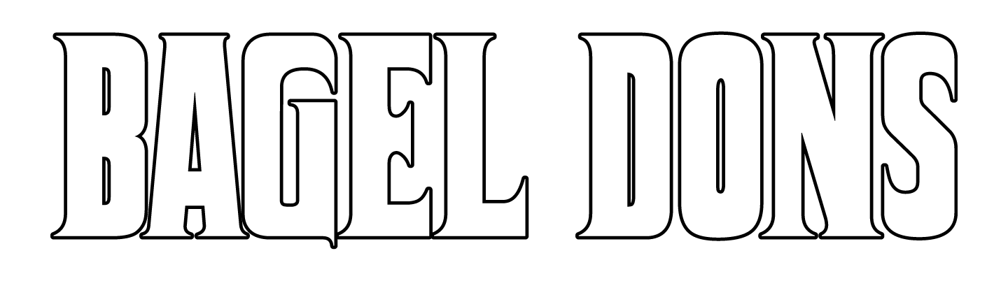
Open 8am-5pm
Wednesday-Sunday
605-689-0171
100 Douglas Avenue Yankton, SD 57078

Credit Card prices listed, 4% discount when paid with cash

Handmade 6oz Bagels:
Plain, Everything, Cheddar, cinnamon sugar
$1.95
Blueberry
$2.44
3.5oz Gluten Free (Udis brand not handmade)
$2.44

4oz Cream cheese:
Plain, Cheddar Jalapeno, Cinnamon Sugar
$1.95
Blueberry
$2.44

Build your own breakfast:
Bacon (x2)
$1.46
Sausage
$1.46
Ham
$1.46
Eggs
$1.22
Toast
$.97
Shredded Hash Brown
$1.95

Breakfast Bagel Sandwich
Choice of meat, 2 eggs, choice of cheese, served on choice of handmade or gluten free bagel (steak sandwich served with a side of lemon aioli)
$9.79
Breakfast Burrito
Choice of meat, 2 eggs, choice of cheese, served in a flour tortilla
$7.83
8oz Steak Tips & 2 Eggs
$9.79
Egg in a basket
Toad in the hole, One eyed jack, birds nest. (slice of texas toast with egg in middle) $2.44
French Toast
2 slices of texas toast sprinkled with powdered sugar and side of syrup
$6.85
Scones
Blueberry, White Chocolate Chunk Raspberry And Apple Cinnamon
$2.93
Biscuits & Gravy
2 biscuits smothered in gravy
$6.85

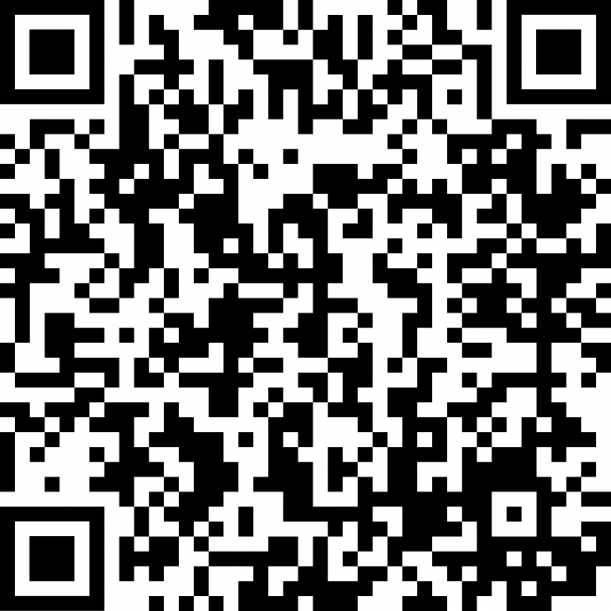
Bagel w/ Lox
Smoked salmon, chive and onion cream cheese, red onion, capers, dill
$14.68
French Dip Bagel/Hoagie
Shredded steak on choice of bagel or hoagie served with a side of au jus
$11.74/9.79
Philly Bagel/Hoagie
Shredded Steak with onions and peppers on choice of bagel or hoagie with provolone cheese
$11.74/9.79
Bagel Burger
6oz Hamburger served with choice of cheese and toppings on choice of bagel
9.79

Side of Cheese Curds
8oz of cheese curds
$6.85
Side of Fries
8oz of fries
$4.89

Pizza Bagel
Breakfast Bacon/Sausage
Gravy base, topped with eggs and mozzarella and choice of meat
$5.87
Pepperoni, 4 meat, cheese
$5.87

*Cheese (American, Cheddar, Provolone, Pepper Jack)
*Toppings (Ketchup, Mustard, Mayo, Pickles, Lettuce, Tomato, Onion)
Syrup Flavors
Vanilla, French Vanilla, Carmel, Hazelnut, Dark Chocolate, Sugar Free Vanilla, Love Potion (vanilla/hazelnut), Caramel Mocha (dark chocolate/caramel)

Drinks:
Canned Soda
$1.22
Fountain Soda
$2.69
Bottled water
$1.22
Orange juice
$2.93
White Milk
$1.95
Chocolate Milk
$1.95

Latte (Hot or Iced)
12 oz
$3.91
20 oz
$4.89

Blended Frappe
20 oz
$5.87

Pot Coffee
12 oz
$2
20 oz
$2.50
Pot Coffee Refill
$0.40

